Pick 2 visualizations to critique / validate based on data-task-idiom models and suggest improvements.

Visualization 1:

<https://informationisbeautiful.net/visualizations/top-500-passwords-visualized/>

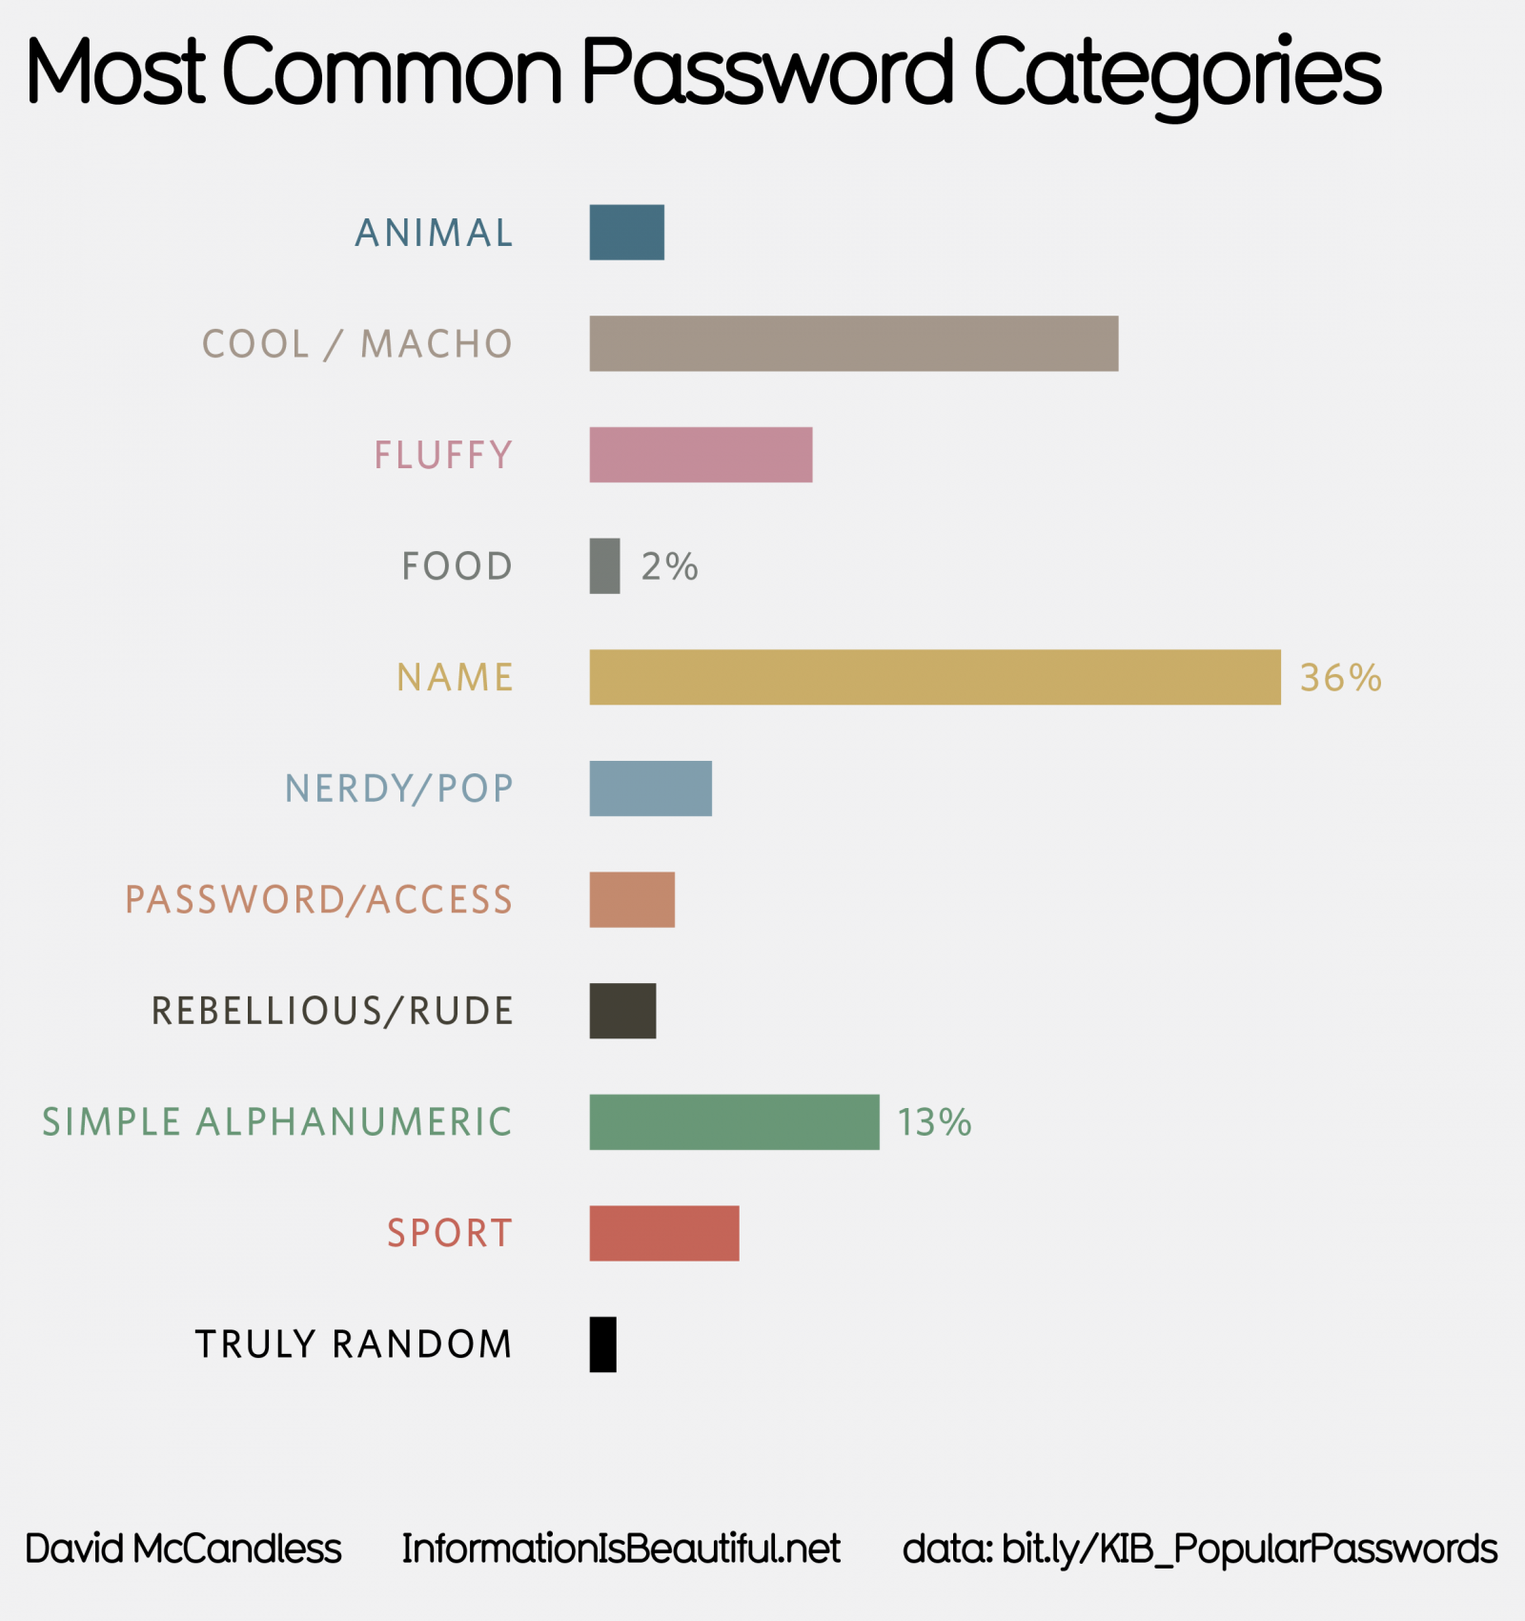

The bar chart that is used to indicate the categories of the most common password does not have a complete figure to indicate the percentage for each of the category data, which proposed the idea that the data may not have 100% as a total figure for the summation of all categories.

Similar data are seen within the bar chart diagram and it's hard to identify the weightage differences within the two categories (Truly random and Food) and within the diagram, there are similar colour coding for the two categories of data that might create confusion for the user when comparing the data within the bar chart diagram.

Solution: First, the data can apply the qualitative palette to make sure that the colour for each of the categories is distinct. As within the current diagram, there are some categories that use the same colour with different hues that could have drawn confusion to the user who are comparing the statistical data within the diagram. Another issue is that the diagram does not contain the full statistic for all the categories, so adding of the statistical text data to the diagram will be mandatory as it will be an aid for the user to better understand the data and to justify its comparison of the bar chart.

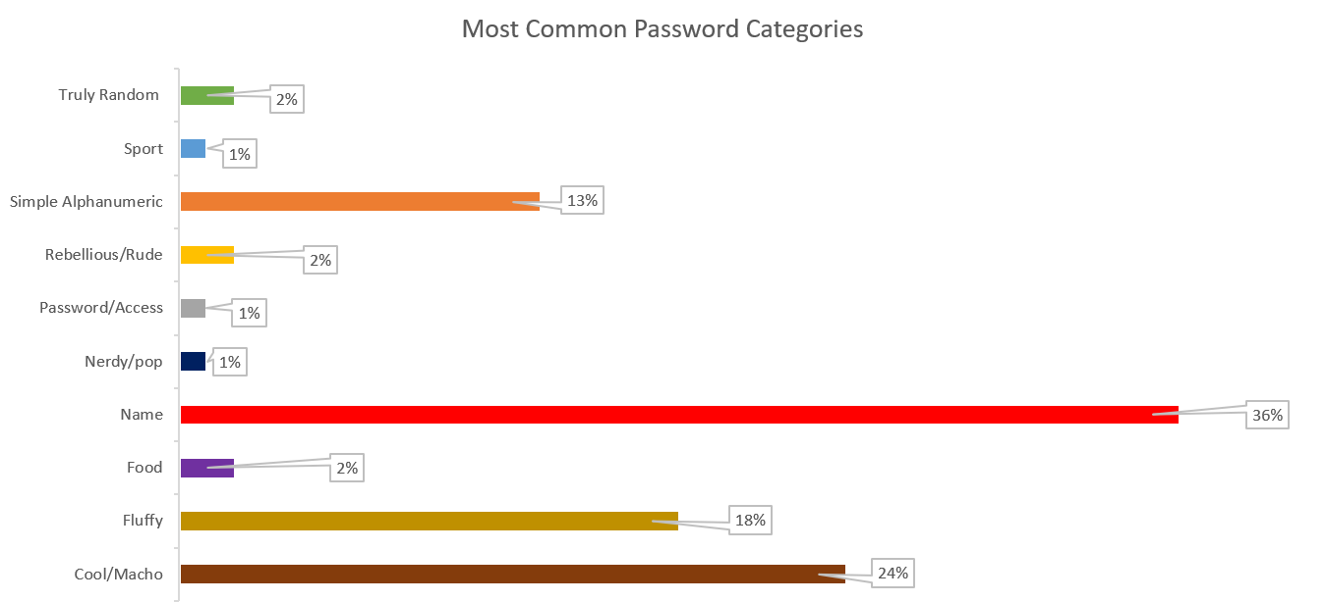

Visualization 2:

<https://09loluic.github.io/CSC3007-assignment2/>

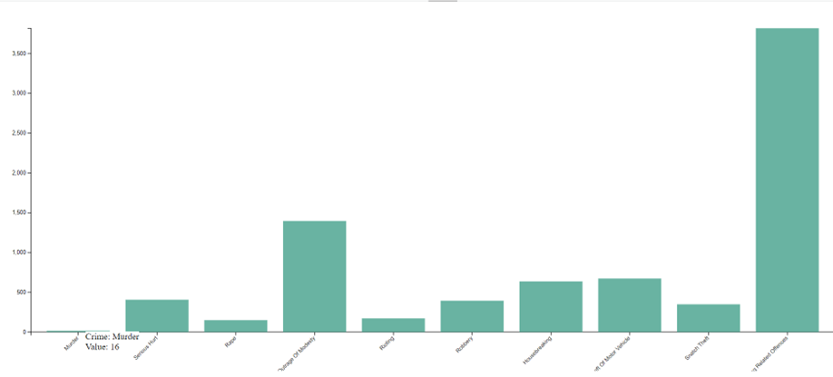

In visualization 2, the diagram indicates the data of crime for each year. However, as there are some specific categories that have extremely high crime rates, there is some data that is hard to be seen by the human eye. Example will be having an extreme low rate for the murder case and extreme high rate for the Cheating related offenses. Even though the diagram provides the tooltip for each of the bars, to display each of the crimes and its value, it will be hard to visualise the actual crime rate due the short-term memory of the humans. Another factor that matters with the diagram is that it uses the same colour for each of the crime categories which makes it even harder for users to visualise and to even create a legend for each of the crime categories.

Solution: To cater with the above-mentioned issues, multiple things can be done to increase its efficiency, as well as to enhance its visualization for the ease of understanding for the user. So first, instead of making use of the vertical bar chart to represent the data, it can also be amended to make use of the pie chart instead, it helps the user to easily identify small portions of data (E.g., Murder case in above diagram), with the Pie chart diagram. And as there are multiple categories of crime within the diagram, the colour coded for each of the data portions would be necessary, so that it will be easily identifiable by the user. Lastly, with the aid of tooltips and legends for each of the colour coded portions, it should be much easier for any user to visualise the data represented.

Solution Visualisation

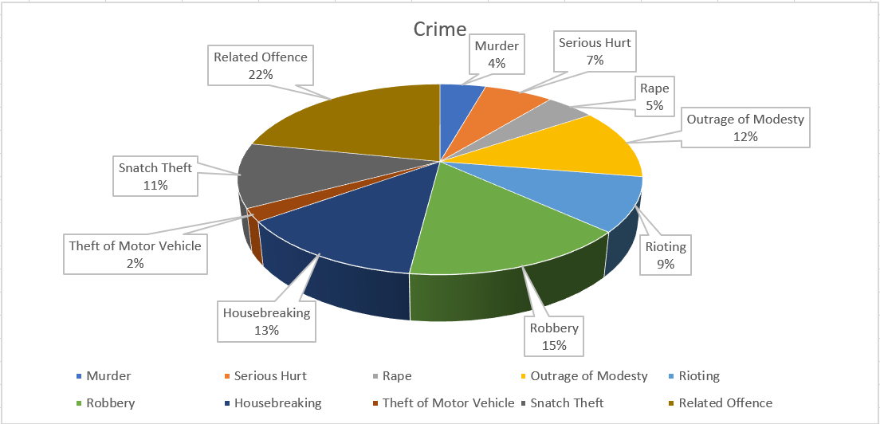

Visualisation 3:

<https://visual.ly/community/Infographics/home/whos-living-together>

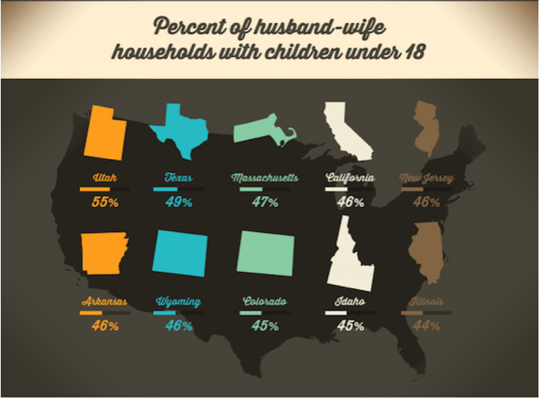

This diagram is taken from an infographic about “The rearranging of Americans Living Arrangements”. The purpose of the diagram is to represent data points for the percent of husband-wife households with children under 18. In the diagram, we see that various states are represented by the outline of the states on the map. The percentages of husband-wife households with children under 18 is represented with a bar graph and the percentage number underneath it.

The first issue with the diagram is that not all 50 states are represented on the diagram above. For an infographic that purports to be describing the rearranging of Americans Living Arrangement, the above diagram is not representative of Americans Living Arrangement. The second issue with the diagram above is that more than 1 state uses the same colour. This violates the colour channel violation of expressiveness principle. The expressiveness principle states that visual encoding should express all, and only, the information in the dataset attributes. In this diagram, the various states with the percentages are considered information in the dataset attributes. Therefore, when more than 1 state uses the same colour, the colour itself does not mean anything anymore. The third issue is that Wyoming and Colorado have the same outline with each other. This might cause a bit of confusion as a viewer might mistook the data for Wyoming with Colorado, and vice versa. Lastly, all the bar graphs look the same even though the percentage values look different. This means that the values in the bar graph are not used correctly as all the values with different magnitudes are displayed the same in a bar graph.

Solution: The above diagram can be put into a horizontal bar chart with the various states listed. The horizontal bar chart will be sorted from states with the highest number of husband-wife households with children under 18 years old. The same colour will be used for all states since there are 50 states and using 50 colours will violate the channel effectiveness of discriminability.

Solution Visualisation

